**PCPF Lab**

**Lab Assignment number 06**

**Name:** Aamir Ansari **Batch:** A **Roll** no. 01

**Aim:** To study and implement pattern Matching and Case in haskell.

**Theory:** Pattern matching is a mechanism for checking a value against a pattern. A successful match can also deconstruct a value into its constituent parts. It is a more powerful version of the switch statement in Java and it can likewise be used in place of a series of if/else statements.

For example, if [1, 2] is matched against [0, bot], then 1 fails to match 0, so the result is a failed match. (Recall that bot, defined earlier, is a variable bound to _|_.) But if [1, 2] is matched against [bot, 0], then matching 1 against bot causes divergence (i.e. _|_).

The other twist to this set of rules is that top-level patterns may also have a Boolean guard, as in this definition of a function that forms an abstract version of a number's sign:

sign x | x > 0 = 1

| x == 0 = 0

| x < 0 = -1

Pattern matching at the function head is compiled, more or less, to case expressions in the function body. Further, your use of case expressions involves pattern matching.

-- Pattern Matching not True = False not False = True

-- Case Expression

not x = case x of True -> False

False -> True

**PROBLEM STATEMENT 1:**

Write a Haskell program to consider a function safetail that behaves in the same way as tail, except that safetail maps the empty list to the empty list, whereas tail gives an error in this case. Define safetail using:

(a) a conditional expression;

(b) guarded equations;

(c) pattern matching.

CODE:

1. Conditional expression;

safetail xs = if null xs then []

else tail xs

2. Guarded equations;

safetail xs | null xs = []

| otherwise = tail xs

3. Pattern matching;

safetail [] = []

safetail xs = tail xs

**OUTPUT:**

1.

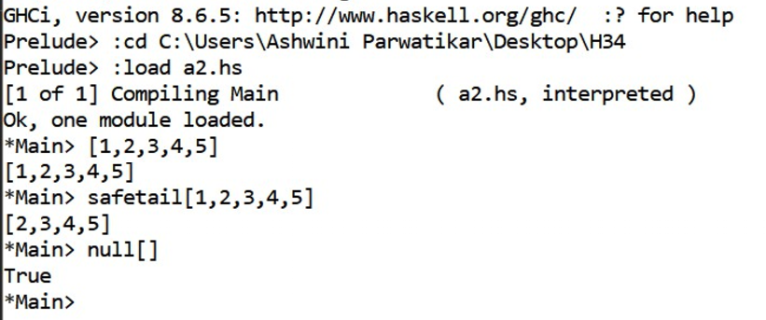2.

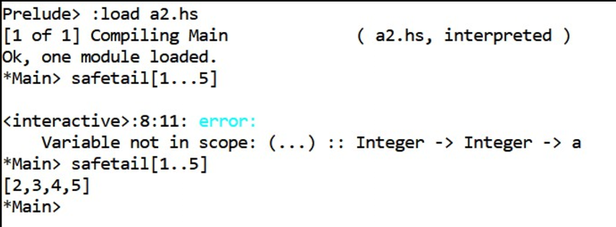

3.

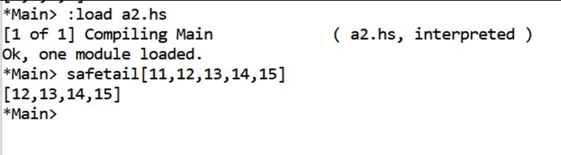

**PROBLEM STATEMENT 2:**

Write a Haskell program to implement a simple calculator. (use case statement)

**CODE:**

solveEqn = do

putStrLn "Enter number 1 "

input1 <- getLine

putStrLn "Enter number 2 "

input2 <- getLine

let a = (read input1 :: Int)

let b = (read input2 :: Int)

putStrLn "Enter the operator from(+,-,/,*)"

oper <- getChar return (case oper of

'+' -> (a + b)

'-' -> (a - b)

'/' -> (a `div` b)

'*' -> (a * b))

main = do

eval <- solveEqn

print ("Answer is " ++show(eval))

**OUTPUT:**

